Matrix manipulations, Graph Translations, and drawing networks (Week 2 Assignment)
(This is adapted from assignment created by James Moody)

Purpose:
This assignment is designed to introduce you to ways of writing networks and the basic software tools used to analyze networks. The traditional way of writing/storing network information is in an adjacency matrix, and many of the methods we use to create network measures involve matrix manipulation. To that end, this assignment includes some basic matrix manipulation exercises.

Tools needed:
- PAJEK : A graph drawing and analysis program. A free version comes with the download of UCINET 6.
- UCINET: Perhaps the most-used network analysis program.

You should use UCINET 6. A trial version can be downloaded for free. We strongly recommend buying UCINET 6, $40.00) as it includes more of the up-to-date measures, a nice graphics interface and some network drawing software.

Writing networks
1) Transform the network below into (a) an adjacency matrix, (b) an adjacency list and (c) an arc list.

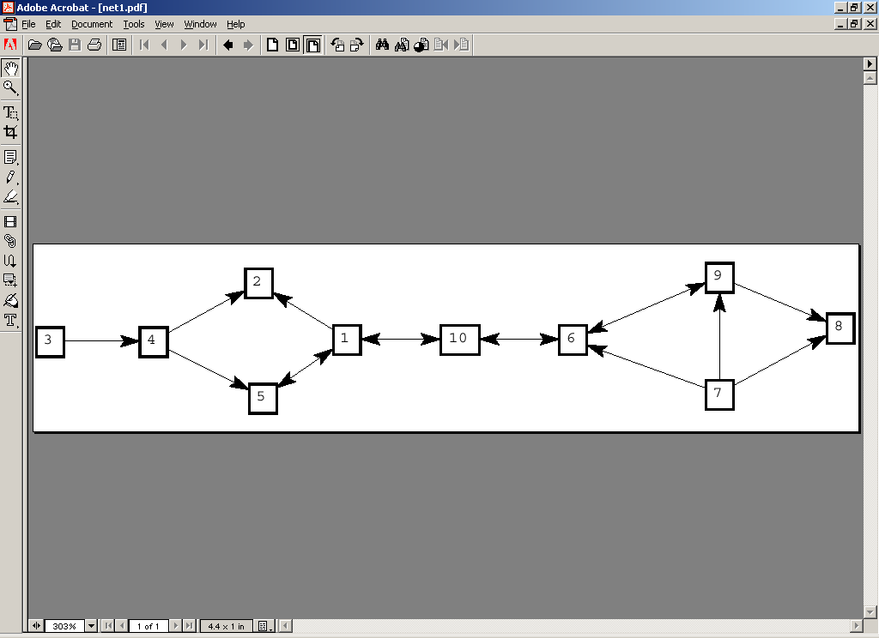

- Transform the following networks into drawings (by hand is fine):

- Adjacency Matrix:
0 1 0 1 1 0
1 0 1 0 1 0
0 1 0 0 0 1
0 1 0 0 1 1
1 1 0 1 0 0
0 0 0 1 1 0

- Adjacency list:
1 6 3 4
2 1 3 5
3 1 2
4 2 3 5 6
5 1
6

Using network analysis software
In each of the following, you will create some data by hand and create a random network. Then you will manipulate the data in various ways. In general, we use programs like Excel to write our data for us, since it is too cumbersome to do it by hand.

- PAJEK. PAJEK is a free network analysis and drawing program. The manual is sparse, though getting better (see their webpage. It basically details every function PAJEK does by walking through the menu). Note that PAJEK comes packaged with UCINET 6 now, though it likely won't be the most recent version (it should be in Analytic Technologies>Helper Apps).
- Create a small network by hand. Input the network in 2a (above). You can do this on-screen or by writing a small program. To do it by hand, use the following steps:
  - Create an empty network. NET>RANDOM NETWORKS > Total No. of Arcs>
  - Then specify the number of NODES (i.e. 6 for 2a above)
  - Then specify the number of ARCS -- since we are going to add them by hand, say 0.
  - Then go to DRAW>DRAW and you should see 6 dots arranged in a circle on the screen. Type Ctrl-N to see the node numbers.
  - Now draw the lines from each node to the other
Do this by right-clicking on the node, which will open a dialog box describing the node's contacts. Double click on NEWLINE. To add a line, designate where it is going. For example, to draw a line from node 1 to node 2, you would enter "-2" (no quotes). To get a line from node 3 to node 1, you would enter "+3".
  - Redraw the graph. Once you have typed in the arcs for a given node, click on the drawing window again (close out the arc editor) and click on "redraw" at the top of the window. You should see the arcs displayed on the screen
  - Once you finish entering the data, let PAJEK draw a nicer picture for you. From inside the DRAW window, go to: LAYOUT>ENERGY>KAMADA-KAWAI>FREE and see what you get. Play with some different layout algorithms, and other options in the DRAW window.
  - When you finish, save the graph. Go to: FILE > NETWORK > SAVE name the graph and close PAJEK. If you then open the file in WORD or TEXTPAD, you will see the program you could have written to do the same thing that you did by hand.
  - Attach a copy of this file in Concourse.

- Create and plot a random network.
  - Random networks are useful for comparing to real networks (and sometimes interesting in themselves, though more so for mathematicians). Create a random network of about 20 nodes and 60 arcs using the same steps as above (when it asks "Network without multiple lines?" say YES. This is asking whether you want more than one relation between any pair of people).
  - Now identify the symmetric relations by going to: NET>TRANSFORM>ARCS-> EDGES>BIDIRECTED ONLY>MINVALUE. If you say YES to make a new network, it will not write over your old one. If you say NO it will.
  - Draw the network, using one of the layout algorithms. Symmetric ties will be BLUE and will NOT have arrows.
  - Print the picture and turn it in.
    - The simplest way to do this is to use the "print screen" button to capture the image and then past it into WORD.
    - If you want to create usable / printable files, use the EXPORT option to save the picture as a bitmap (.bmp) or as a postscript file (EPS), which you can then edit in other programs.
- UCINET
- Create a small network by hand. Input the network in 2a (above). To do it by hand, use the following steps:
  - DATA>SPREADSHEETS>MATRIX
  - Click in the spreadsheet window to make it active. You can now type your matrix directly into this spreadsheet. Do so.
  - Then save the file FILE>SAVE> and name it. Note this creates a UCINET file, which really has two parts, neither of which you can read in a text editor, a .##h file and a.##d file. This is transparent unless you start moving files aroundsomewhere.
  - Now display the data. Go to DATA>DISPLAY> and load the filename you just saved.
  - Turn in the results (Just copy-and-paste it).
  - If you are using UCINET 6, try drawing the network. Click on the 'draw' file at the top of the screen, which will take you to NETDRAW (If it doesn't you may have to look around the drive for NETDRAW). Then use FILE>OPEN to open the file you just saved. It should display on the screen. Note the features of NETDRAW, allowing you to include nodes and such.
  - To see the kind of program you could write to generate this network (instead of typing it in by hand), export it as a .DL file. Go to DATA>EXPORT>DL and follow the prompts. Note that you could also read in an EXCEL file.

- Create and plot a random network.
  - DATA>RANDOM
  - Here you will see many options for creating random networks. For now, use MATRIX
  - Then choose matrix size (20) and number of levels (i.e. types of ties) - say 1. Then choose a random distribution. Since we want a zero-one matrix for now, use binomial, and set diagonal to be NOT valid. Click OK then pick a value for event probability which in this case is the density (the proportion of cells that have ties). Once you set your options, click on OK to generate the matrix. Turn in the result.
  - If you have UCINET 6, draw the network using the same steps you did above.

- Reachability
- Take the adjacency matrix in 2a (call it A) and compute A*A (A² ) using matrix multiplication. If you are not familiar with matrix multiplication see example in W&F p. 158.
- You now have two matrices, A and A² . From these two matrices compute the distance matrix (D) by placing in the cells of D the corresponding value from A or A² which is smaller. Hand in the D matrix. Look at your picture of A that you drew earlier and see if the distances are correct.
- Use UCINET to recalculate this distance matrix. To do this reload the file that you created with UCINET in 4a (c). Do this by going to DATA>SPREADSHEETS>MATRIX and then FILE>OPEN and browse for the file you created. Then back in the main USINET window go to NETWORK>COHESION>DISTANCE. Then click OK (if you want you can change where the output goes. Compare the results to the ones you obtained by hand. They should be the same. Hand in the results. (Note: UCINET will give you one cell with a distance of 3 which you will not get in your distance matrix unless you do A³)

